Fltterning sql table data

create table emp_information

(

empid int,

empname varchar(100),

skills varchar(100),

address varchar(100)

)

insert into emp_information values(101,'srinivas','python|Hadoop|Azure','{"city":"Hyderabad","country":"INDIA"}');

insert into emp_information values(102,'Phani','SQL|Pyspark|ADF','{"city":"Hyderabad","country":"INDIA"}');

create table emp_information_final

(

empid int,

empname varchar(100),

skill1 varchar(100),

skill2 varchar(100),

skill3 varchar(100),

city varchar(20),

country varchar(20)

)

1. Create tese two tables in sql
2. We have get flatterned information from table 1 and add it to table two as skills and city, country
3. Now go to df
4. Create dataflow
5. Add source to table 1
6. Create dataset but use legacy

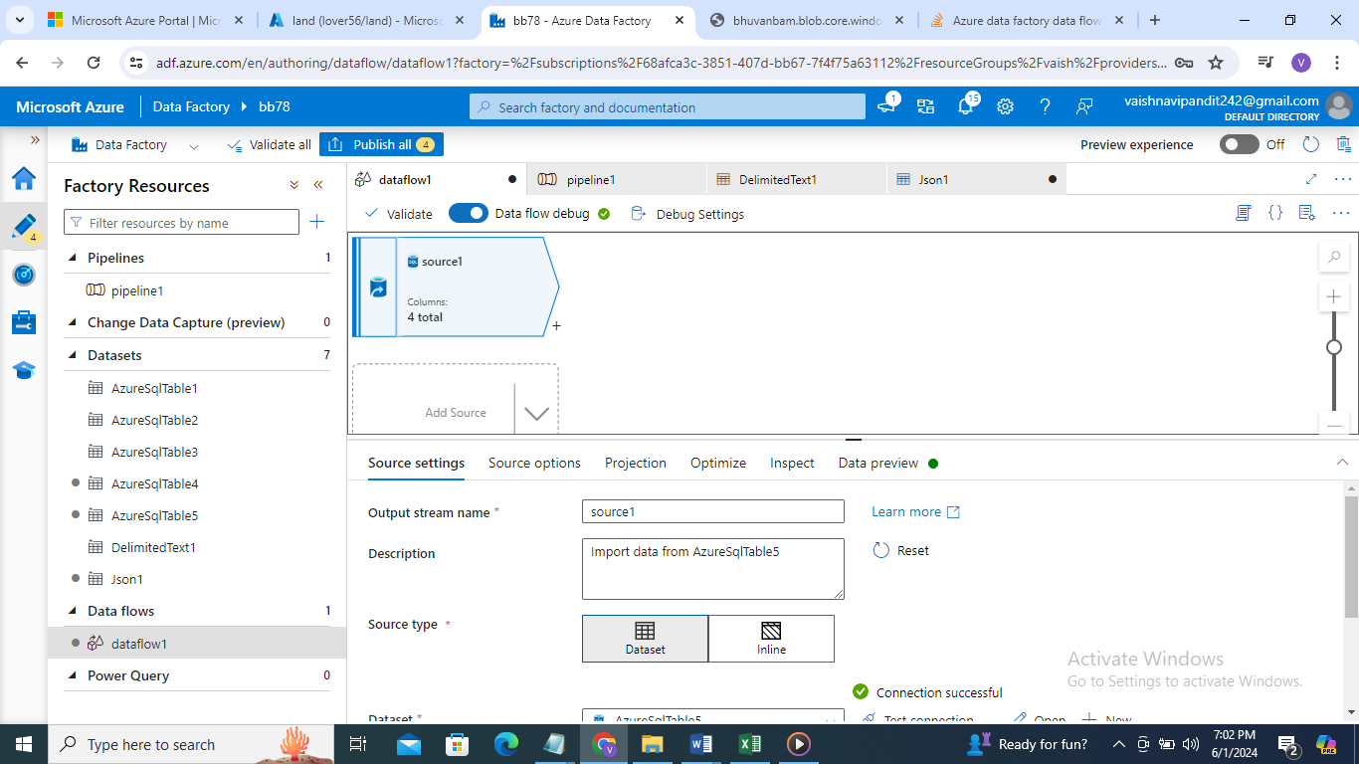

1. Projection->import

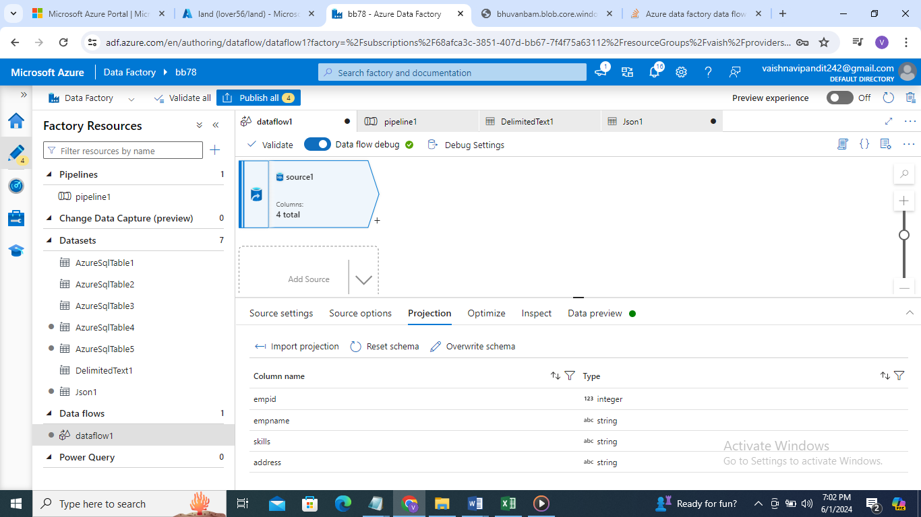

1. See preview skill are not separated

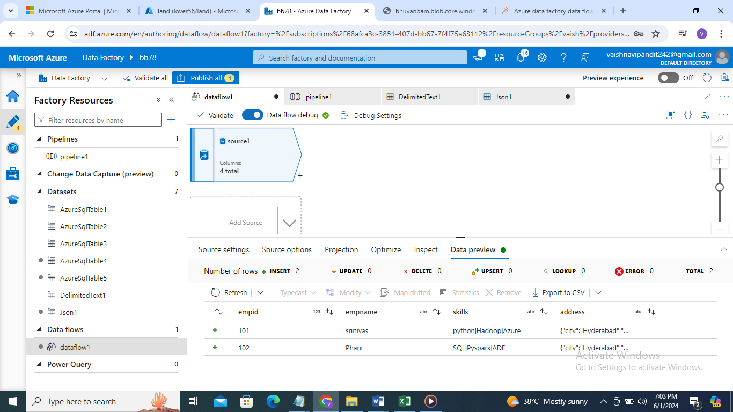

1. Now click on + and select parse

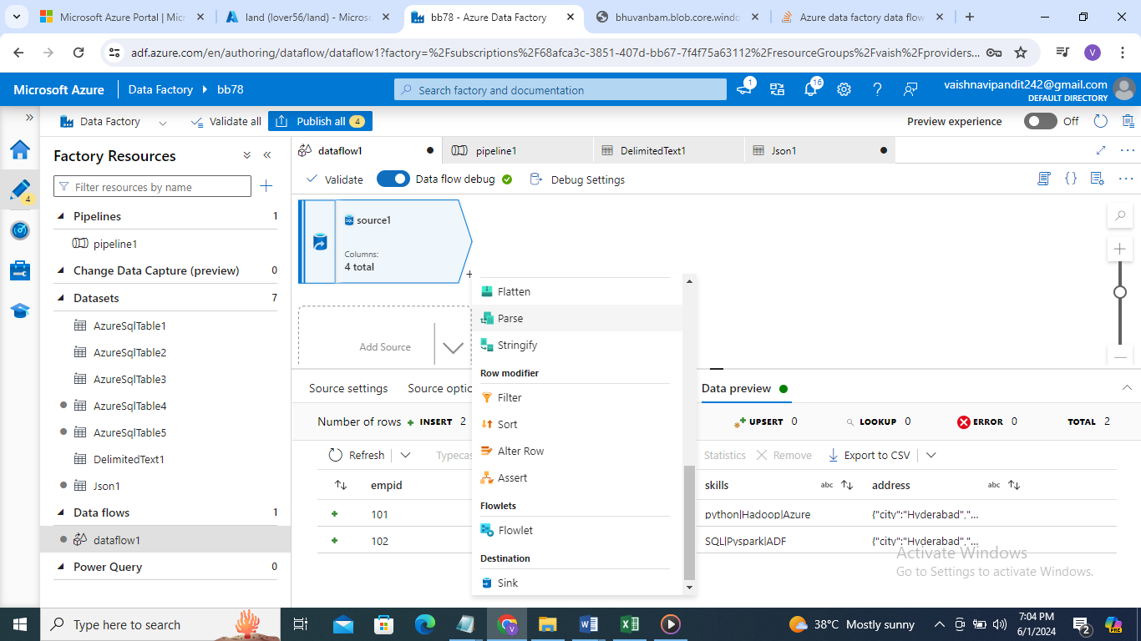

1. Go to parse

Select delimeted text for skills

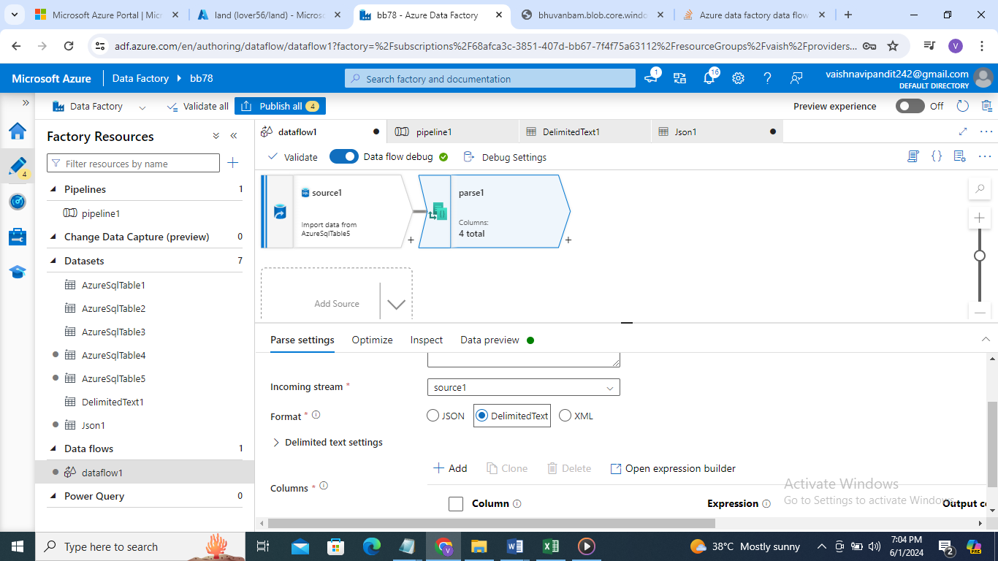

1. go to delimited text settings

column delimeter select pipe

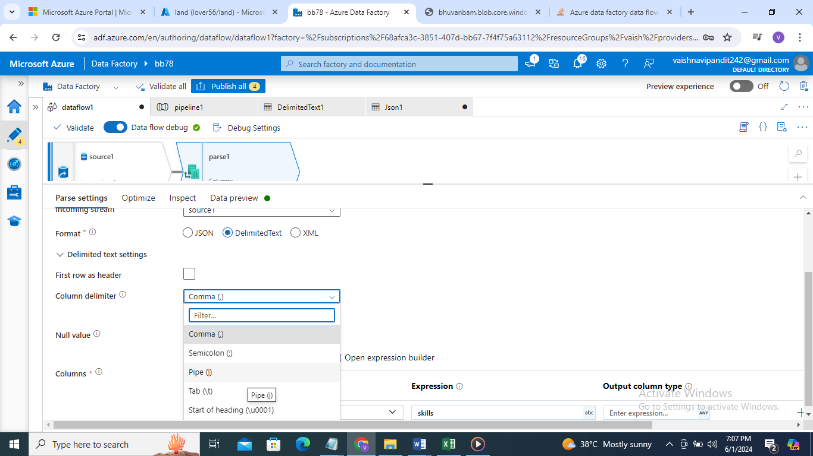

1. go to column add skill ->in expression skills->in output column type(skill1 as string , skill 2 as string, skill 3 as string)

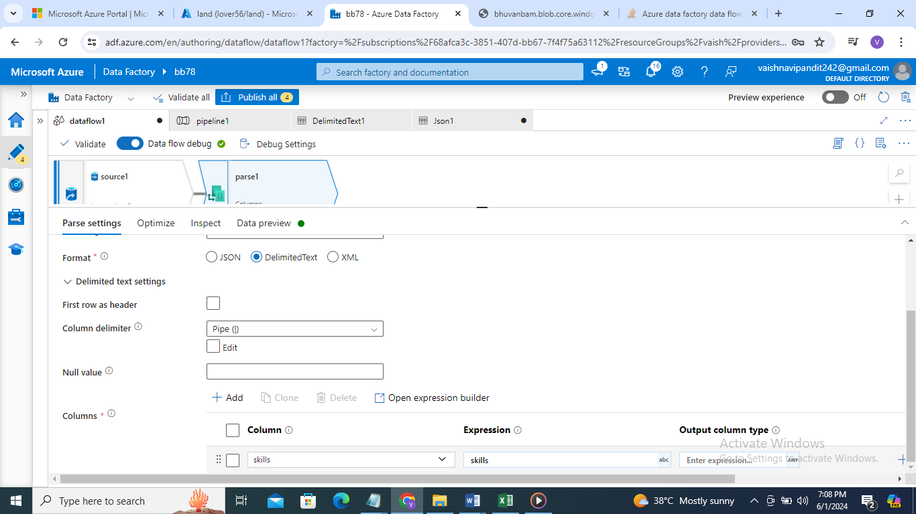

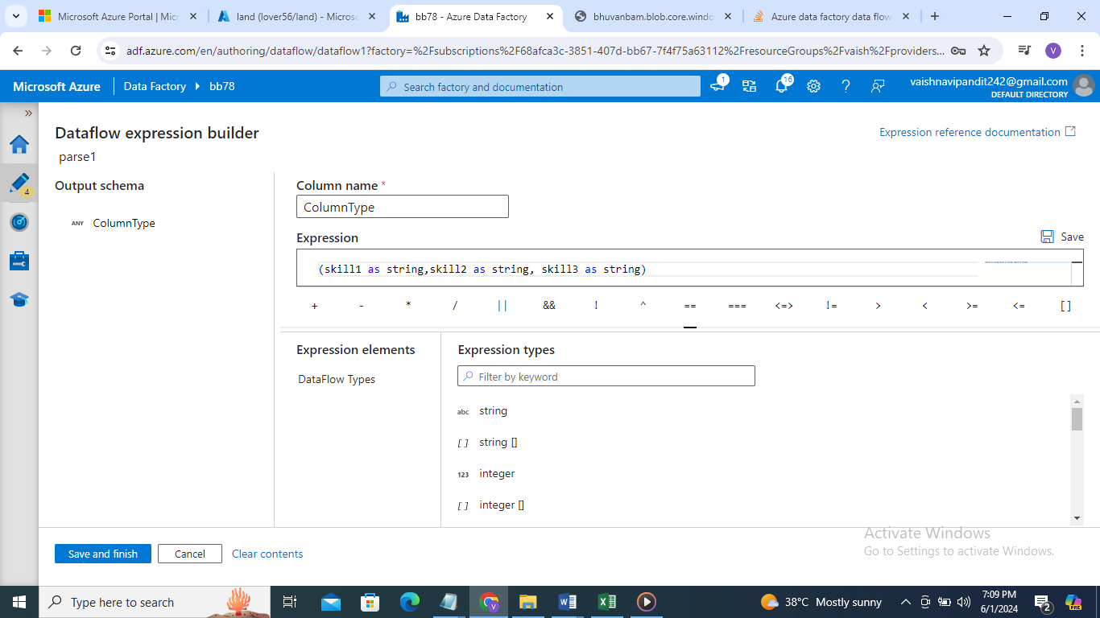

1. go see data preview skill column is flattern and skill 1 skill 2 skill 3 columns are generated

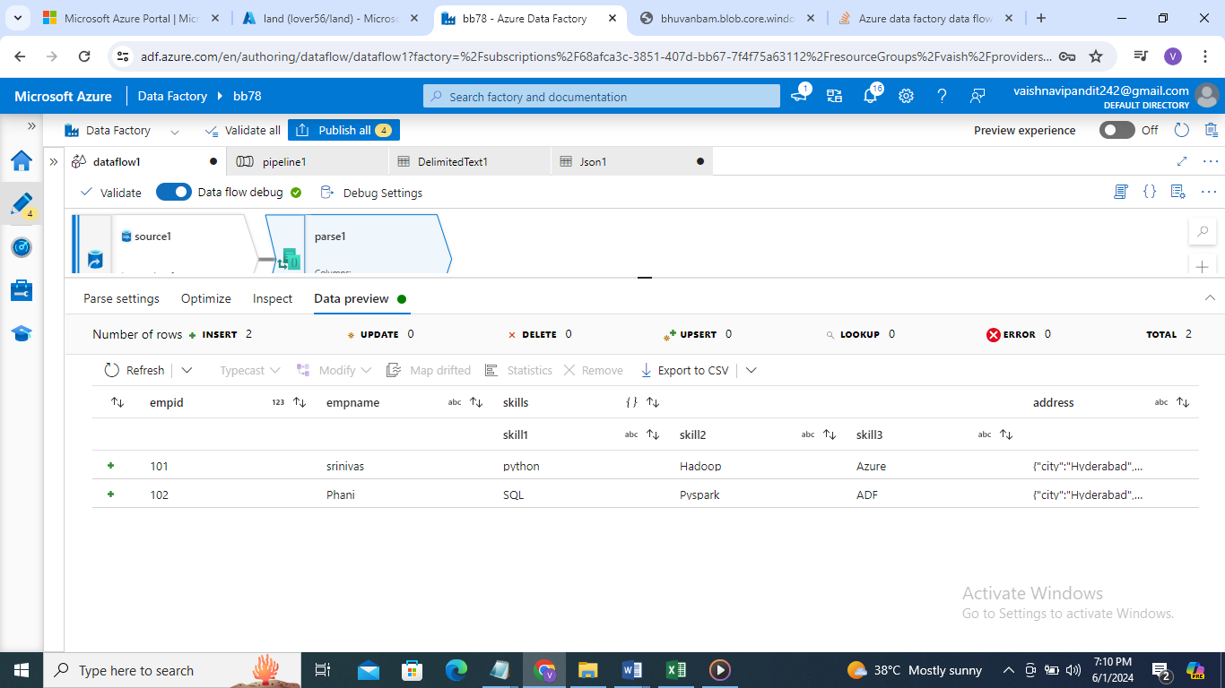

1. now click + again create parse

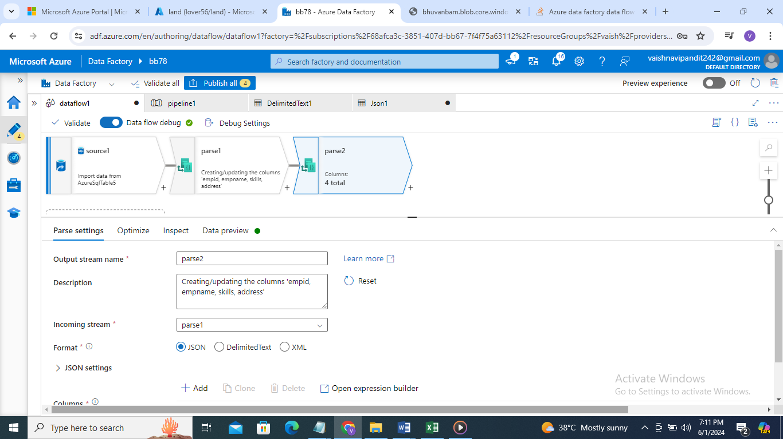

1. go to parse format json json settings->array of document column->address in expression address in outptut column type->(city as string, address as string)

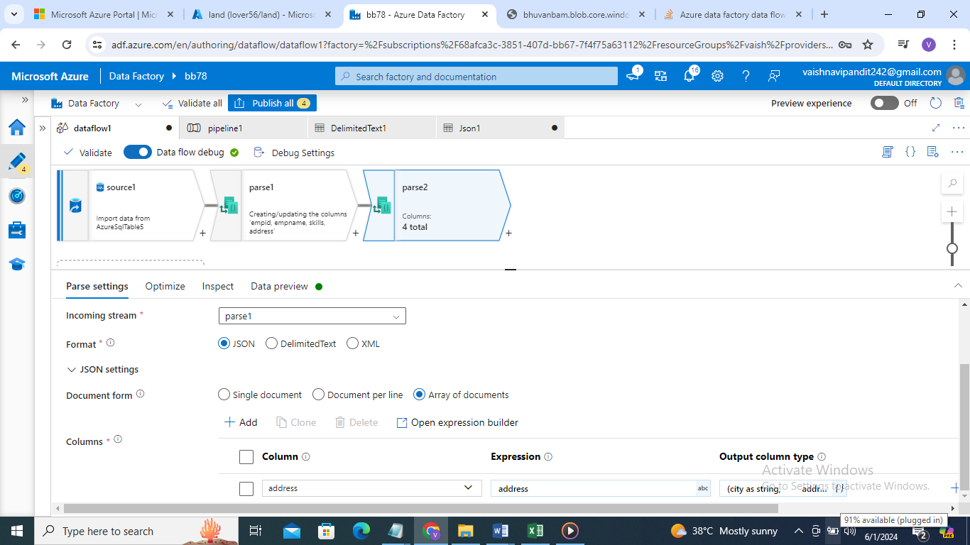

1. go see preview

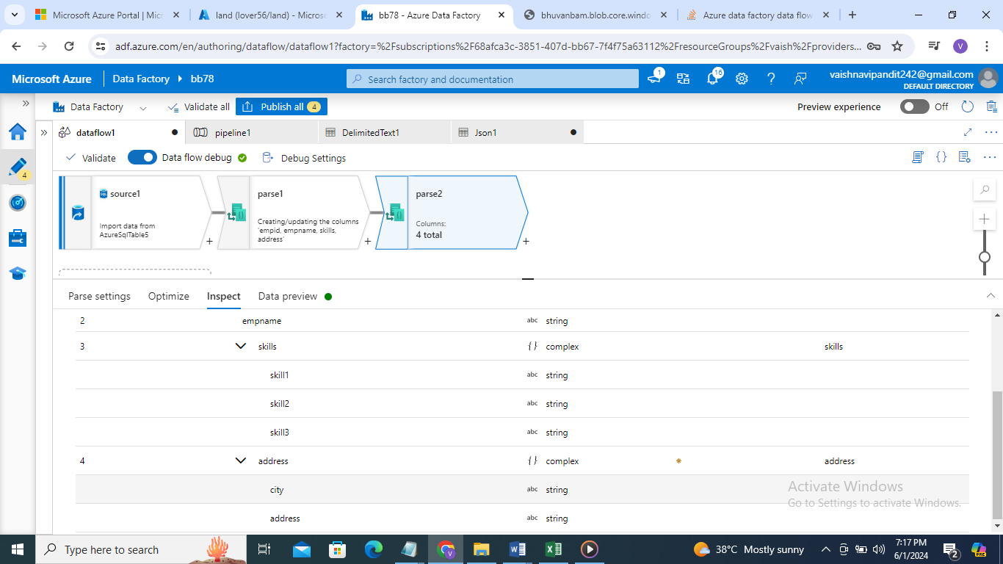

1. now create select activity to upload data in final table table 2

using fixed mapping for city country and skills

click on skills add mapping ->fixed mapping

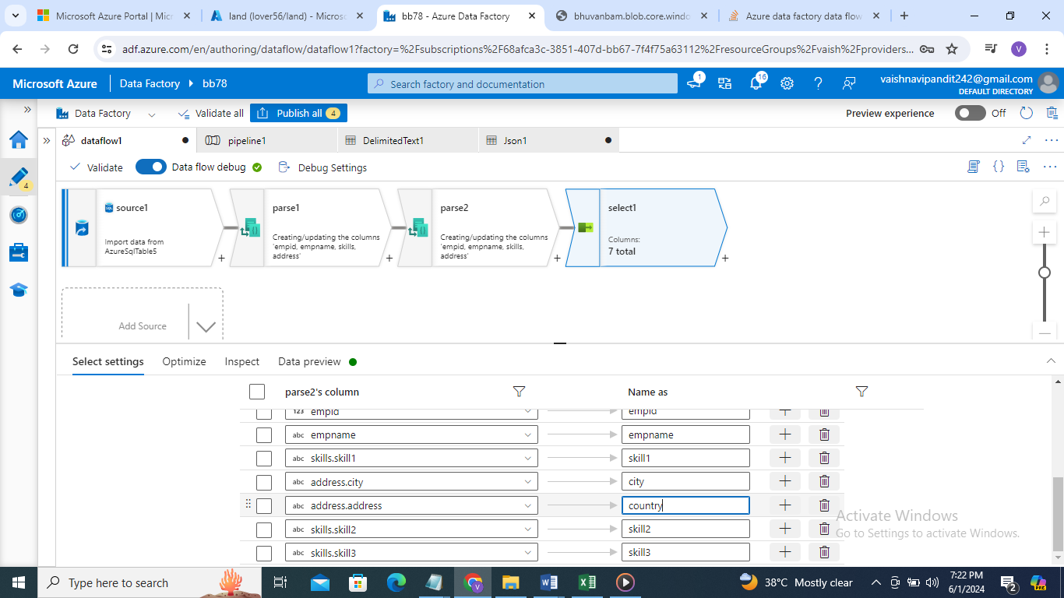

1. now add sink for sql table 2
2. and add pipeline debug